
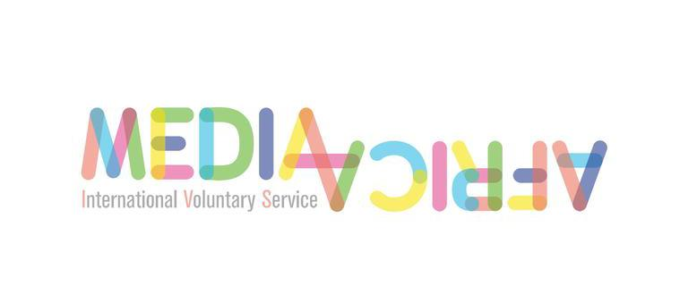
MediAfrica’s WORKSHOP

Target : European people 18-30 years old, who are going to volunteer in Africa soon or who are potential international volunteers (even if they haven't taken the decision yet).

Group: 10-20 people

Time: 2 hours

Resources:
- a computer with Internet connection + projector for facilitator(s)

- if possible, 3 computers for the group of participants. If not, available WiFi connection to use their smartphones

- Papers, post-it and pens.

OBJECTIVES

- To identify stereotypes on different cultures or nationalities

- to learn how to manage the “cultural shock” by developing intercultural skills

- To better understand volunteering: the purpose of a volunteering program and the role of the volunteers

- To promote IVS as a community where to work around peace building and social justice

DESCRIPTION

This workshop is thought to support the preparation process of people who is going to volunteer in Africa, as well as to inspire potential volunteers to do it (people who is thinking in volunteering but they are not sure yet, or they haven't decided where to do it)
So it is an introduction to intercultural exchanges as well as to international volunteering, its impact and the role of the volunteers in it.
The proposed itinerary starts from an individual or personal perspective, reflecting on challenges and insecurities; the next step is to be aware of stereotypes and other cultural constructions and representations to finally address international volunteering within worldwide framework.

All media that we will use come from the webdoc created in the framework of MediAfrica project. This workshop has been also designed as a result of the project, taking as starting point the needs and expectations expressed by both sending and hosting organizations of volunteers in Africa.

This sequence of activities is a proposal that can be worked independently, or that can be adapted depending on the group of participants, the available time, the needs of the organization, etc.

Activity 1: Fears The fears that we share // The emotions that we share // What we share

This first activity aims at exploring emotions when facing an intercultural experience. When volunteers are about to start their program, it is common to be afraid or to have doubts before getting in touch with a different culture, traveling to another country, etc... There is a responsibility when being a volunteer, as they are aware that they represent much more than themselves (this is one of the messages that they must receive in preparation sessions)
But are Europeans the only people feeling these fears or doubts? Could we say that only volunteers are the ones trying to manage these cultural or social issues? Let's try to answer by discovering that human emotions are shared above all cultural gaps or borders.

- Individual task. Every participant of the workshop writes on a paper which are her/his main fears or doubts before starting a volunteering program.

- The big group splits in 3 small groups. Each small group will watch a video and will discuss about the content, trying to make links with what they wrote in step 1 (it is not necessary to share it, just to reflect around the video in relation with those notes)

- The videos that will be used are:

- Julia's nightmare
- Henri
- Franklin

- Big group of all participants. We share the conclusions of every small group and we try to find what they have in common.

- Big group. We watch fragments of videos talking about the fears or the doubts expressed by the hosting community:

- Mzungu School
- Family from Togo

- Big group. Conclusions: fears and doubts about intercultural experiences are universal emotions.

Activity 2: How to manage “cultural shock” without relying in stereotypes // Stereotypes, knowledges and intercultural skills

In this second activity, we will work around stereotypes. They are cultural constructions built by communities when trying to deal with differences or unknown cultures. Then, all societies use stereotypes to define their relationships with other societies or cultural groups but... are we always aware that we use them? Do we know how do we build them or where are they based on? Is it possible to avoid them? Stereotypes are exclusively Europeans?

- Big group. We watch a fragment of Togo's video when Estella talks about the meaning of holding the hand of someone in Togo, and what volunteers usually think.

- Individual task. Every participant writes in post-its their answers to the following questions (one idea per post-it)

a) What do you think you know about the country where you are going to? (if you are not a volunteer yet, try to imagine which country you would choose to volunteer)

- b) Which are your sources? Where did you learn what you answered to question a?

We stick every post-it on a wall or similar. There will be no names, only the ideas.

- Big group. We watch 2 videos:

- Tia about UNICEF, embassy and media
- Henri about media and African representation.

- Big group. We share our conclusions after watching the videos and trying to link these conclusions to what we have in the wall. Possible questions to enliven debate:

- Which ideas from the wall and from the videos could be similar, or even the same?
- The sources of information, are the same for you and for them?
- They talk about the representation of African people in media, does it match with what you wrote in the post-it?
- Could we say that some of “those things that we think we know” are stereotypes? Why? Where do they come from?

- Big group. We watch “Suits, suits, suits”. Stereotypes go both ways.

- Brief theoretical explanation about stereotypes: definition, how do they work, etc..

Activity 3: Volunteering: our purpose, our role and the impact that they can have.

In this third step, we are going to focus on volunteering. As this workshop is thought to be implemented before the participants go to volunteer in African organizations (or to inspire them to do it), the participants should have an accurate knowledge about the purpose of volunteering, the role of volunteers in the project and in the hosting organizations, and the impact that their presence could have in the community where they would work.

At this point of the workshop, the participants should be more comfortable with their peers in the group and should feel more confident to express their feelings or opinions. So we will implement this third activity on the basis of collective thinking to achieve solutions that are shared by an heterogenous group with a same expectation: to volunteer.

- Which is your role as a volunteer? In big group, we watch Mathilde's video.

- Collective Thinking: in big group, we will have a debate around the video and the experience of Mathilde:
(proposal of questions to enliven the debate)

- Do you think that there is an evolution in Mathilde as a volunteer? Is there any change in her? Which one(s)?
- In your (collective) opinion, what is more relevant in volunteering, the cultural friendly encounters or the project itself?

- International Volunteering: is it the only way to volunteer? In big group, we watch the video “Portrait of Claire”, then we continue our collective thinking:

- Did you know that African organizations count on local volunteers for their daily activities?
- After watching the video, what have you learnt that you didn't know? Is there something impressive that you think that European volunteers should know?
- So, if there are local volunteers in African organizations, which would be the role of the international ones?

- The impact of the international volunteers: Mzungu School
- Brief explanation (if necessary) retaking all conclusions developed in this activity
- The real purpose: video of Spanish and Ugandan volunteers.

Activity 4. Round Trip Volunteering: a tool for volunteers and for social organizations.

Finally, we propose to save some minutes to screen the webdoc, the details around it (the name “Round Trip Volunteering”, where to find it – url or organisations websites, etc) and to explain that all media used during the workshop come from there
We also propose to show how to move within the webdoc and where to find practical informations:
- How a guest house looks like (The arrival)
- How you will be introduced to the place and the project (Around nansana)
- Togo: Adi et l'animatrice
- How it is a communitary project: Kikooba School

The purpose of this activity is not to play these videos but only to point them as to point the webdoc itself as a place where to find practical informations about volunteering in Africa.

